Stimuli and Performance Exploring
- Are there levels where performance is extreme (almost always correct or almost always wrong) and several intermediate levels where performance is not at ceiling or floor?

Gap | Total trials | Hits | Hit Rate | D-prime
1 | 42 | 10 | 0.2381 | 0.1993
2 | 36 | 18 | 0.5000 | 0.9117
3 | 42 | 26 | 0.6190 | 1.2147
4 | 36 | 21 | 0.5833 | 1.1222
5 | 42 | 33 | 0.7857 | 1.7034
6 | 42 | 39 | 0.9286 | 2.3770
7 | 36 | 34 | 0.9444 | 2.5050
8 | 36 | 31 | 0.8611 | 1.9971
9 | 36 | 35 | 0.9722 | 2.8262
10 | 48 | 45 | 0.9375 | 2.4459
11 | 36 | 35 | 1.0000 | 3.1122

Table 1: Table 1: Hit Rates and Sensitivity Index (d') Across Stimulus Gap Levels
Based on the data in Table 1, the performance across the stimulus groups clearly demonstrates both extreme and intermediate levels of sensitivity. The most difficult stimulus, Gap 1, shows a near-floor performance with a hit rate of approximately 24% and a low D-prime of 0.1993. Conversely, the easiest stimulus, Gap 11, reaches the ceiling with a perfect hit rate of 100% and a high D-prime of 3.1122. Extreme high-performance levels are also observed in Gaps 6, 7, 9, and 10, where hit rates consistently exceed 92%. In contrast, Gaps 2 through 5 and Gap 8 represent the intermediate levels, as their hit rates and D-prime values sit between the extremes. These intermediate levels are the most valuable for the study because they avoid the mathematical limitations of floor and ceiling effects.

- Does hit rate increase as the difference between figures increases?
Yes, there is a positive trend that has been observed in a correlation graph (Figure 1) between the difficulty levels and the d’. It gives an indication which stimuli contribute to the variance better. As the difference between the figures becomes larger sensitivity increases. This is exactly what we expect. For the levels 2–5 and 8, the d′ increases gradually and there is variability between levels. So, this is the most informative part of the scale. Levels 9-11 approaching ceiling effects and less informative and level 1 is very difficult, so performance is close to floor (almost no discrimination).

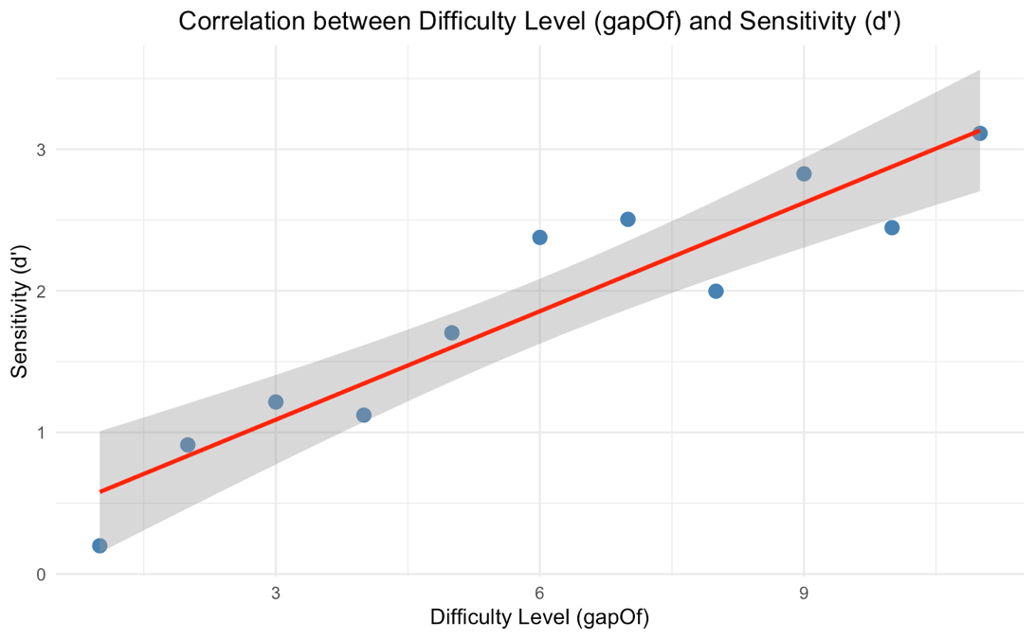
Figure 1: Correlation between difficulty level and d prime.

- Is there any extreme effect of the orientation?
Conditions | Hit | Miss | % Hit | % Miss
0_vs_minus30 | 45 | 15 | 75 | 25
0_vs_plus30 | 68 | 16 | 80.95 | 19.04
minus30_vs_0 | 72 | 30 | 70.58 | 29.41
minus30_vs_plus30 | 45 | 15 | 75 | 25
plus30_vs_0 | 41 | 13 | 75.92 | 24.07
plus30_vs_minus30 | 57 | 15 | 79.16 | 20.83

Table 2: Comparison of Detection Accuracy and Error Rates Across Orientation Conditions
Based on the data in Table 2, there is no evidence of an extreme effect related to the orientation conditions. Specifically, the minus30_vs_plus30 and plus30_vs_minus30 groups yielded hit rates of 75% and 79.16%, respectively. These values demonstrate that performance remains well-distributed and does not hit the "floor" or "ceiling" performance. Because the participants are neither always correct nor always wrong, these stimuli are highly effective for measuring sensory thresholds. This stability across orientations suggests that the direction of the tilt does not disproportionately hinder or help the participant's detection ability.

